Why do we use Normalization in SQL?
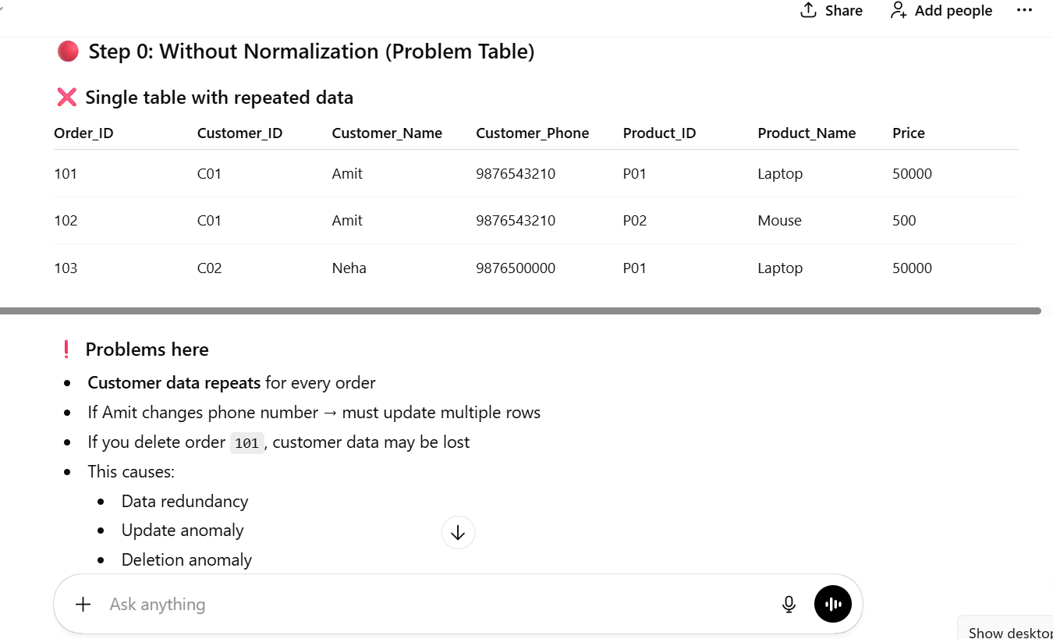
Normalization is used in SQL to reduce data redundancy, avoid anomalies, and maintain data consistency and integrity by organizing data into well-structured tables.
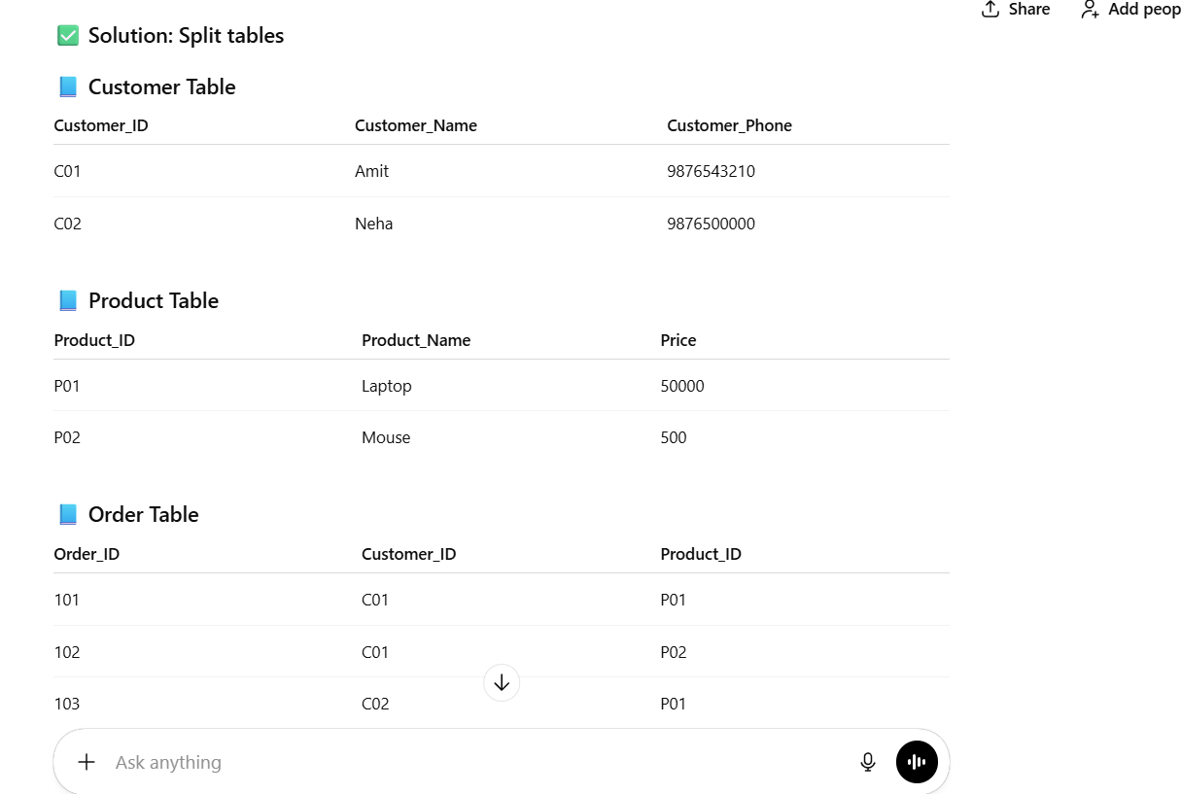

,mm

